**QUICK FATIGUE TOOL FOR MATLAB®**

**Stress-based Fatigue Analysis Code for Finite Element Models**

# Tutorials

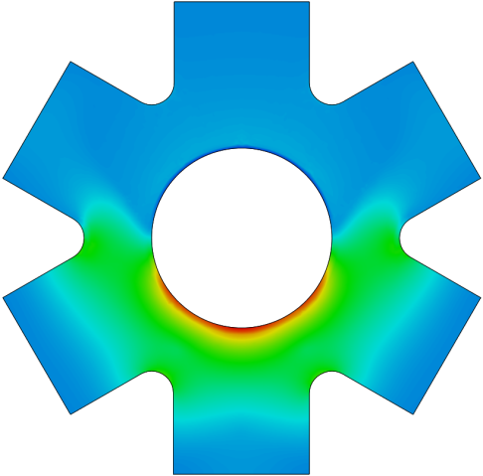

**© Louis Vallance 2017**

# Version Information

**Documentation revision: 1 [8/02/2017]**

**Concurrent code release: 6.10-02**

Contents

Tutorials 1

Version Information 3

# Tutorial 1: Uniaxial and Multiaxial Fatigue Analysis

## 1.1 Introduction

In this tutorial you will become familiar with the process of using Quick Fatigue Tool (QFT) to perform simple fatigue analyses. You will create a fatigue analysis using first a uniaxial load case, then a multiaxial stress dataset.

It is recommended that you first read Section 2 “Getting started” of the *Quick Fatigue Tool User Guide* before proceeding with this tutorial.

## 1.2 Preliminaries

If you have not already extracted the downloaded QFT files, perform the following steps:

1. Extract the folder *qft6xxx.zip* to a directory of your choice. The chosen directory should have full read-write permissions.
2. Start MATLAB and enter the root QFT directory. This should be *DRIVE:\...\6.xx-yy*.
3. Ensure that the folders *Application_Files* *Project* are included on the MATLAB search path. Highlight both folders, right-click and select **Add to Path → Selected Folders and Subfolders**. The MATLAB UI should look similar to that of Figure 1.1.

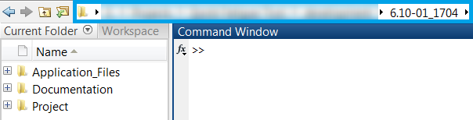

Figure 1.1: MATLAB UI with all QFT files included on the MATLAB path